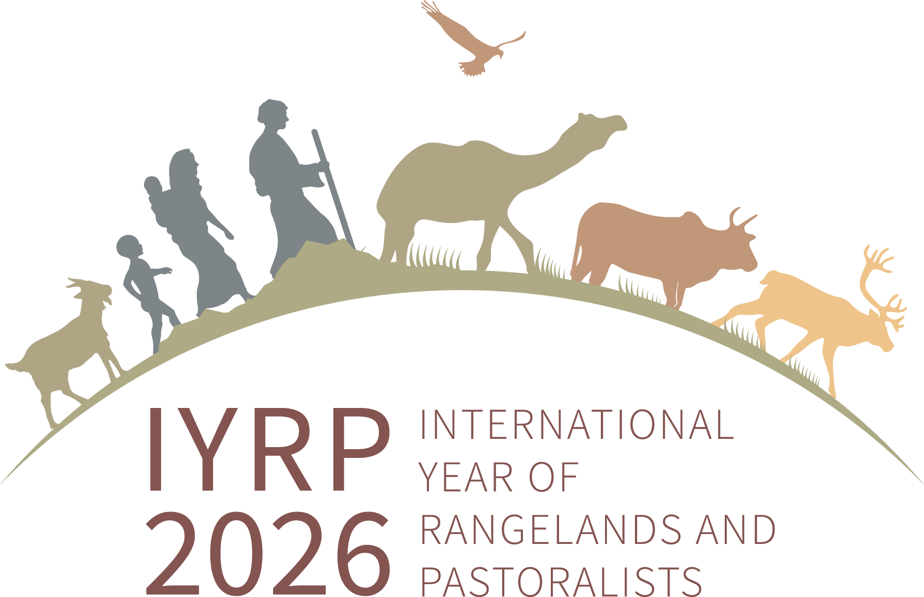
Rangeland Stories Film Festival Competition
Are you ready to share your story?

Due Date: November 1, 2023
Film length: 3-10 minutes
Contact: Courtney Buchanan
cbuchan3@uwyo.edu

The IYRP North America Film Festival seeks entries that tell stories of rangelands and the people that live and work on these lands. We invite students, producers, rangeland professionals, and professional filmmakers to submit short films (10-minute maximum length) that highlight experiences with or understandings of rangelands. Films may tell a rangeland story that connects personal experiences to broader issues rangeland managers face in the 21st century such as:
- sustaining biodiversity
- providing ecosystem services
- producing livestock sustainably
- creating systems resilient to droughts and climate.
Topics may also be focused on one of the 12 monthly themes of the IYRP (see graphic below).

This is a unique opportunity to tell captivating stories for diverse and new audiences that can help spread the appreciation and importance of rangelands. Selected films will be highlighted during a virtual event this coming winter (likely at SRM and at a Rangelands Partnership 2024 annual meeting), during other IYRP outreach activities, and shared on the IYRP North America website. Imagine audiences in Los Angeles, Denver, Seattle, or New York viewing your film - what impactful experiences in rangelands can you share?

Timeline & Logistics

- Start filming now! Capture your rangeland experiences, interview co-workers or family members about their experiences, or document some of your field projects. The submission deadline is November 1^{st,} 2023, and results will be announced January 2024.
- Films should be uploaded to YouTube for submission and judging. Once uploaded, email to Courtney Buchanan (cbuchan3@uwyo.edu) the link to your film along with your name, category you want to enter, and contact info.
- Films will be judged according to the rubric below. The two categories will be judged separately.
- For more information see https://www.iyrp.info/north-america/film-projects/film-festival.
- More information about the 12 IYRP themes can be found on the IYRP website: https://iyrp.info/outreach-materials/front/12-themes.

Categories
Amateur Filmmakers
- Students, livestock producers, or other rangeland professionals without film experience
- New or existing films specific to this call

Professional Filmmakers
- Films created by established film makers or outreach groups
- New or existing films that fit this call
Film Festival Rubric
Message
- Clearly fits at least one of the 12 monthly IYRP themes (See list below) – 10 points
- Story relatable to a diverse audience, not just those involved in range production or rangeland management – 15 points
Film Quality
- Complete, within 10 minute maximum – 5 points
- Video formatted correctly for viewing and uploaded to YouTube – 5 points
- Smooth transition of film from scene to scene – 10 points
- Quality of film: light, angles, focus etc. – 10 points
- Adequate pacing of short film, sections do not feel rushed or too long – 10 points
Storytelling Ability
- Creative title that generates interest in the topic – 5 points
- Captivating story that holds the viewer's interest – 10 points
- Clear, logical, flow of the story – 10 points
- Any visuals, text, or narration support one another and build the story together – 10 points
TOTAL POINTS POSSIBLE = 100
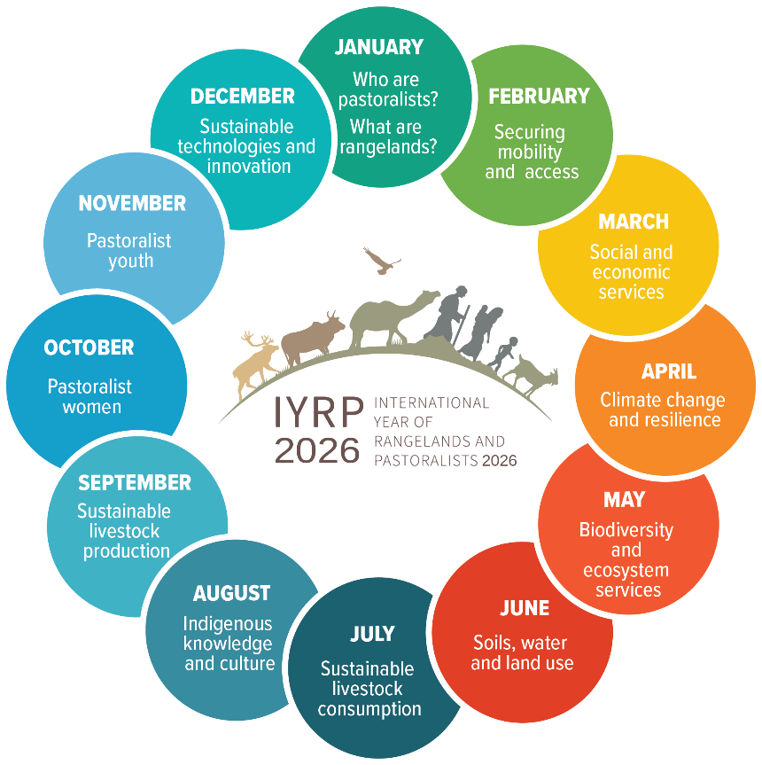
Proposed Twelve Monthly Themes

